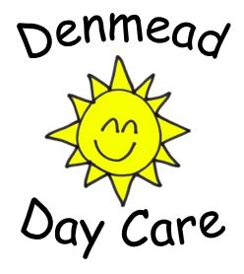
Risk assessment

Policy statement
Denmead Day Care believes that the health and safety of children is of paramount importance. We make our setting a safe and healthy place for children, parents, staff and volunteers by assessing and minimising the hazards and risks to enable the children to thrive in a healthy and safe environment.
The basis of this policy is risk assessment.
- Identification of risk: Where is it and what is it?
- Who is at risk: Childcare staff, children, parents, volunteers, visitors etc?
- Assessment as to the level of risk as high, medium, low. This is both the risk of the likelihood of it happening, as well as the possible impact if it did.
- Control measures to reduce/eliminate risk: What will you need to do, or ensure others will do, in order to reduce that risk?
- Monitoring and review: How do you know if what you have said is working, or is thorough enough? If it is not working, it will need to be amended, or a better solution is found.

Procedures
- Our risk assessment process covers adults and children and includes:
- checking for and noting hazards and risks both indoors and outside, and within individual activities.
- assessing the level of risk and who might be affected;
- deciding which areas need attention.
- We maintain lists of health and safety issues, which are checked daily (bathroom, kitchen, garden etc) before the session begins as well as those that are checked on a yearly basis when a full risk assessment is carried out. If there are any problems, then the yearly risk assessment is added to as and when necessary.
- It is down to all the staff to ensure that daily risk assessments are carried out.
- A risk assessment form is to be filled in both morning and evening to ensure nothing is missed.

Policy updated on 10 July 2011
Reviewed on 10 July 2012
Reviewed on 24 July 2013
Reviewed on 21 September 2014
Reviewed 27 January 2015
Reviewed 26th February 2016
Reviewed and amended 29 March 2017.
Reviewed 26 October 2017
Reviewed 25th October 2018
Reviewed 02 September 2019
Reviewed 31st March 2020
Reviewed 23rd August 2021
Reviewed 3rd February 2022

